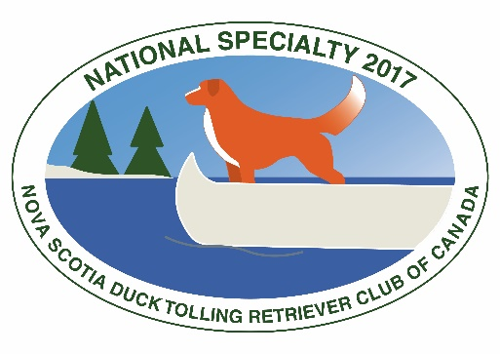
NATIONAL SPECIALTY 2017

HOSPITALITY

MEALS & MEETING

Name(s): ______________________________________________________

Address: ______________________________________________________

City: ___________ Province/State: ____________ Postal/Zip Code: ________

Country: ______________________ Telephone: _______________________

Email: _________________________________________________________

BBQ Saturday evening at Long Sault (Minimum 50 places reserved, so please book early)

Regular ($20) Quantity: _______ Cost: $_______
Children (under 12) ($10) Quantity: _______ Cost: $_______

ANNUAL GENERAL MEETING Sunday at Best Western

AGM 5:00pm Quantity: _______

BANQUET Sunday at Best Western (Minimum 100 places reserved, so please book early)

Cocktails 6:00pm Dinner 7:00pm

Regular ($40) Quantity: _______ Cost: $_______
Vegetarian ($20) Quantity: _______ Cost: $_______
Children ($20) Quantity: _______ Cost: $_______

TOTAL Included $ ___________

Method of Payment? |  | Card Number: | Expiry Date: | Signature:
 | VISA
 | MASTER CARD
 | CHEQUE
 | eTRANSFER

Please make CHEQUES payable in Canadian funds to the "NSDTR Club of Canada" OR
eTRANSFERS to abongers@hotmail.com

Please mail form to “Specialty, 1149 Hartwell Rd, Ottawa, Ontario K4M 1E5” OR
email to hospitality@toller.ca
MENU

SATURDAY BBQ:
Under the Gazebo at Show Site
Pork, baked beans, corn on cob, salads, coffee, tea and desserts.
$20 all inclusive ($10 children 12 and under)

SUNDAY BANQUET DINNER:
Best Western Cabaret Room

Fresh Dinner Rolls & Butter
~
Garden Salad - A mixture of Iceberg, Romaine & Radicchio lettuce with shredded carrots, cherry tomato, cucumber and red onion. Served with an Olive Oil & Herb Vinaigrette.
~
Supreme Chicken - Seasoned 10oz supreme breast of chicken. Pan seared then oven baked. Served with a housemade demi-glace.
Garlic Asparagus
Rosemary, Thyme & Garlic roasted baby potatoes
~
New York Cheesecake with Fresh Berries and Chocolate Drizzle (gluten and lactose free also available)

Coffee or Tea
$40 Includes HST and 15% gratuity.

VEGETARIAN:
Veggies in a Veggie (Vegan/Vegetarian/Gluten Free) - Yellow pepper stuffed with rice and stir fried veg. Topped with FAB sauce.
$20 Includes HST and 15% gratuity.

KIDS:
Salad, Chicken Fingers and Fries, Dessert and choice of beverage (Pop, Juice or Milk)
$20 Includes HST and 15% gratuity.

WINE WITH DINNER: Wine list on the tables.

BEVERAGE – Cash Bar

