NOVA SCOTIA DUCK TOLLING RETRIEVER CLUB OF CANADA
MEMBERSHIP APPLICATION & RENEWAL and BREEDER DIRECTORY FORM 2018
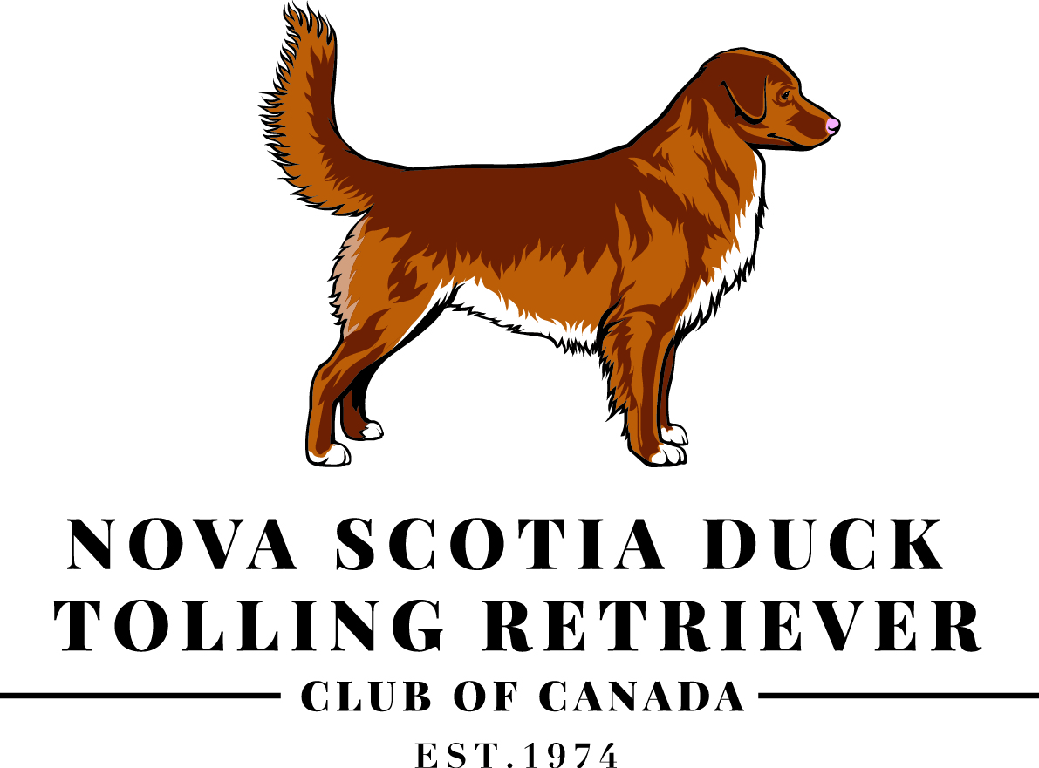

NEW MEMBER RENEWAL BREEDER SPONSORED**
Membership Type:
Canada-Individual | $25 |  | Family | $40
Jr. Handler with household | $10 |  | Jr. Handler stand-alone | $20
United States-Individual | $30 |  | Overseas-Individual | $35
Breeder Directory | $20

Membership fees are due January 1st and are applicable for a calendar year.
Dues paid after October 15th are considered for the following year. **Late renewals may be left off the annual Membership Roster.**
I do not want my name included in the annual Membership Roster.
I/We, wish to apply for membership to the Nova Scotia Duck Tolling Retriever Club of Canada in the category indicated above. I/We agree to abide by the Constitution and By-Laws of the NSDTR Club of Canada and to honour its Code of Ethics as printed on the second page of this form.

Name(s):
Address:
City: |  |  | Province/State: |  |  |  | Postal/Zip Code:
Country: |  |  | Telephone: |  |  |  | Fax:
Email: |  |  | Web Address:
Signature(s): |  |  |  |  |  |  |  | Date:
 |  |  |  |  |  |  |  | Date:
Kennel Name: |  |  |  |  | Tattoo Combination:
Registered Name(s) of Toller(s) Currently Owned: |  |  |  |  | Call Name(s):
1. |  |  |  |  | 1.
2. |  |  |  |  | 2.
3. |  |  |  |  | 3.
4. |  |  |  |  | 4.

Enclosed: |  |  | $ |  | Membership Dues | $ |  | Breeder Directory
$ |  | Dobirstein Fund | $ |  | Toller Rescue Fund | $ |  | Health & Genetics Fund
$ |  | Scholarship Fund |  |  |  | $ |  | TOTAL

Method of Payment: |  | Card Number: | Expiry Date: | Signature:
 | VISA
 | MASTERCARD
 | cheque | Please make cheques payable in Canadian funds to the "NSDTR Club of Canada"
- If you require a receipt, please include a Self Addressed Stamped Envelope.
- Mail application forms along with applicable funds to: Colin Davies PO Box 204, Almonte, Ontario K0A 1A0 membership@toller.ca
**Breeder Sponsored Membership is a membership purchased by the breeder for an entire litter. Contact Colin or visit www.toller.ca for details.
--PLEASE KEEP THIS PAGE FOR YOUR RECORDS--
NOVA SCOTIA DUCK TOLLING RETRIEVER CLUB OF CANADA CODE OF ETHICS
This document is the Code of Ethics adopted by the NSDTR of Canada on July 1, 2008.
The purpose of the NSDTR Club of Canada Code of Ethics is to foster the well-being of the breed and to encourage a uniform high standard of breeding. It emphasizes the Toller's original purpose as a tolling and hunting retriever by maintaining all characteristics of type, including but not limited to intelligence, hunting ability, temperament and conformation.
All prospective members will affirm that they will comply with the Code of Ethics by signature on their application for membership. Each member will reaffirm compliance annually by signature when membership is renewed.
Member's Responsibilities:
• Members should educate themselves on all aspects of responsible dog ownership. Every Toller owner is encouraged to disclose health information to the NSDTR Club of Canada Open Health Registry. Dogs must be maintained with their good health and safety in mind, including but not limited to grooming, feeding, veterinary care, housing, training, socialization and exercise.
• Members shall be courteous, cooperative and responsible, respecting and not denigrating another Member in good standing. The integrity of the Club is to be upheld in all dealings.
• Whenever and wherever Members compete with their Tollers, they will behave with decorum and due regard for the requirements of the host organization, its venue and at their lodgings.
• Members shall also place the health and well being of their dogs above the pursuit of awards. At all times they will conduct themselves so as to reflect well on the Nova Scotia Duck Tolling Retriever Club of Canada.
• All members should be willing to assist in placing any homeless Toller, if possible.
Definition of a breeder:
A breeder is defined as "any person who owns, leases or is responsible for any bitch or dog that is bred, with the intent of producing at least some of the litter for sale."
Responsibilities of breeders:
• Breeders should take back, or assist in relocation of, any dog they produce, for the dog's entire life.
• Ethical breeders are constantly aware of the responsibilities of breeding to foster the natural abilities, character, breed type and health of Tollers. With the Canadian Kennel Club Standard as their blueprint and current health information and tests as tools, healthy working companions with good breed type should be the goal of every breeding.
• Breeders shall avoid knowingly producing puppies affected for diseases where genetic testing is available, except in cases of test breedings required for research. Test breedings shall be done only in partnership with an accredited research facility.
• Breeders will stay current on and utilize new technologies that may be developed to screen for additional genetic disorders.
• Breeders recognize that dogs selected for breeding should be of temperament appropriate for the Nova Scotia Duck Tolling Retriever: stable, loving and playful with his family, but may be aloof with strangers. Dogs shall not be overly shy or aggressive and shall be trainable and willing to work. Temperament is of utmost importance to the breed and must never be neglected.
• Breeders shall provide buyers with the documented results of any health and/or genetic tests carried out on the dog being purchased, and on its sire and dam. They will also make such results available to the Club's Open Health Registry.
• Breeders shall also provide buyers with written details of feeding, veterinary and general care.
• When planning a litter, breeders should have prospective buyers in mind for pups they do not intend to keep. Breeders are encouraged to share the names of prospective buyers if unable to meet buyers. needs in a reasonable amount of time.
• Breeders shall register all dogs with the Canadian Kennel Club, or the applicable governing body of the country in which they reside. Within six months of date of sale (or when all pre-existing agreements between breeder and buyer have been met), breeders shall provide buyers, at no extra cost, with registration papers for all dogs sold, a current CKC breed standard and at least a three-generation pedigree. Accurate records shall be kept of matings, pedigrees, sales, transfers and health information. Members shall not, in any circumstances, knowingly be a part of or contribute to a false registration.
• To protect the integrity of the breed, breeders shall utilize one of the following: CKC Non-breeding Agreements, co-ownerships and/or private contracts, for all dogs sold from their kennel. Breeders will provide honest and clear information about their Tollers to prospective buyers prior to the actual sale.
• All stock should be at least seven weeks of age before leaving the breeder's premises.
• All advertising shall be factual. If statements are made concerning health status, documentation shall be supplied upon request.
• Members will not, to the best of their knowledge, sell or consign any animals to pet stores or other commercial outlets, to contest sponsors, dealers, or to persons under CKC or any breed club censure. Members will attempt to sell, permit stud service, lease studs or bitches only to those individuals who give satisfactory evidence that these animals will be given proper care, and who are in agreement with this Code of Ethics.
• Breeders are encouraged to demonstrate to buyers that the breeder adheres to the Code of Ethics and to provide a copy of it to every buyer.
Breeding Practices:
Breeders should educate themselves on diseases found in the breed, so that sound decisions can be made to maintain breed health, type and integrity. A thorough knowledge of pedigrees should be used to avoid doubling up on diseases, thereby working towards reducing the incidence of these conditions by careful selection.
All breeding stock shall be:
• Healthy dogs over the age of 18 (eighteen) months and bitches not more than 8 (eight) years of age.
• Certified clear of hip dysplasia by a recognized institution, e.g. OFA, OVC, PennHip.
• Certified clear of hereditary eye diseases by a veterinary ophthalmologist before breedings: the recommendation is yearly or a maximum of 18 (eighteen) months between examinations.
• Tested to determine the progressive rod-cone (prcd)/PRA and CEA (collie eye anomaly) DNA status 'Clear, Carrier or Affected' if unknown by parentage.
• Suitable spacing of litters for any one bitch shall be practised, with top priority given to the health, welfare and quality of life for the bitch. Previous litter size and age of the bitch should be carefully considered before any breeding. A bitch should not produce more than 5 litters or 32 offspring in her life.
Enforcement:
• Following rules in Article V of the Club By-laws, any complaint alleging contravention of this Code shall be set out in a letter to the Secretary of the Club. The Executive will investigate the matter, without delay. If it is determined that the member is in contravention of this Code, the member will be sent a letter outlining the Code's guidelines and expectations for member conduct.
• If the member is reported and proven to have repeated the contravention, the member will be immediately removed from the breeder.s referral list and will no longer be permitted to advertise in Toller Talk, or in any documentation of the Nova Scotia Duck Tolling Retriever Club of Canada including the website. In order to be reinstated, proof that the contravention has not recurred must be given to the executive. The executive will determine, by vote, if the member may once again advertise their kennel through the club and be listed in the breeder's referral.
• If any breeder chooses not to sign the Code of Ethics with their membership renewal, they will not be permitted to promote their kennel through any club venue, including newsletters, the club website and the breeder's referral.
• Any member of the Nova Scotia Duck Tolling Retriever Club of Canada who, in the opinion of the Executive, contravenes this Code of Ethics may be subject to reprimand, suspension or expulsion from the Club's Breeder's List, and/or from Club membership as provided for in the Club By-Laws, Article V.

