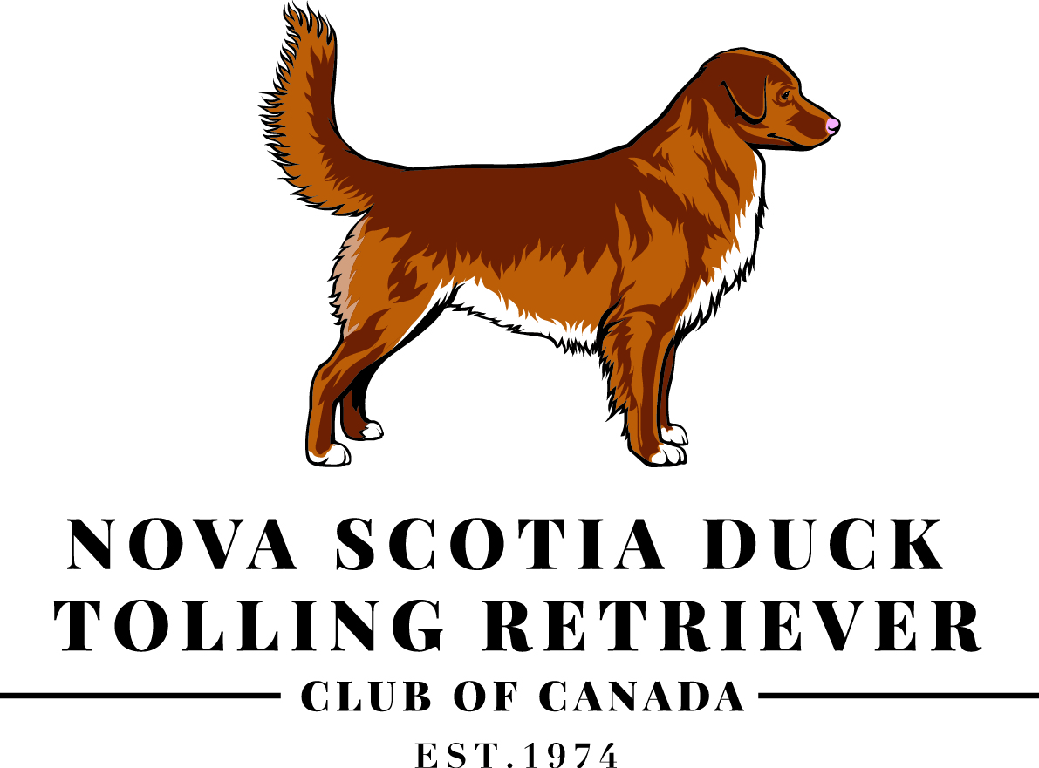 | NOVA SCOTIA DUCK TOLLING RETRIEVER CLUB OF CANADA  REGISTER OF MERIT/ REGISTER OF MERIT EXCELLENT APPLICATION  The NSDTR Club of Canada Register of Merit award is available to all  members of the Nova Scotia Duck Tolling Retriever Club of Canada.*

Name(s):
Address:
City: |  |  |  | Province: |  |  |  |  | Postal Code:
Telephone: |  |  |  | E-Mail: |  |  |  |  | Date:
Applying for: |  |  | Register of Merit |  |  | Register of Merit Excellent |  |  |  | SIRE |  |  | DAM

Registered Name of Dog (CKC titles only):
*I/We confirm that I/we have been member(s) in good standing of the Nova Scotia Duck Tolling Retriever Club of Canada for one year or longer. I/We confirm that all information provided is correct and that all required documents are enclosed, complete, and correct. I/We understand that more information may be required in order to confirm eligibility.
Name of Owner(s) |  |  |  |  |  | Name of Breeder(s)
Signature of Owner(s) OR Breeder(s):
PLEASE DO NOT SEND ORIGINAL DOCUMENTS AS THEY WILL NOT BE RETURNED
PLEASE (E)MAIL ALL APPLICATIONS TO: |  |  | Dawn O’Leary  6830 Fernbank Road, Stittsville, ON L2S 1B6
QUESTIONS? CONTACT: |  |  | 613.831.9961  doleary@xplornet.com
CLUB USE ONLY |  | Date Received: |  | Date certificate mailed:
Date Web Site Administrator notified: |  |  |  | Date Toller Talk Notified:
PROGENY
PLEASE READ ALL ROM AWARD REQUIRMENTS CAREFULLY BEFORE COMPLETING APPLICATION
      - List progeny used to accrue points for this award.
      - List progeny by their CKC registered name (do NOT include non-CKC or honorary suffixes & prefixes), CKC registration number, title being used for points (both CKC and non-CKC titles by recognized organizations), points earned for title.
      - List progeny in the following order: those that fulfill the CHAMPIONSHIP requirement first, those that fulfill the FIELD title requirement second, all remaining dogs.
1) | CKC REGISTERED NAME, CKC REGISTRATION NUMBER |  |  |  |  |  |  | TITLE | POINTS
2)
3)
4)
5)
6)
7)
8)
9)
10)
11)
12)
13)
14)
15)
16)
17)
18)
19)
20)

APPLICATION / DOCUMENT GUIDELINES

APPLICATION / DOCUMENT GUIDELINES
NAME(S) | 1. Applicants must be the owner or breeder on record of the qualifying ROM(X) sire or dam.  2. Name(s) on the certificate will be as they appear on the application.  3. Each owner will receive a certificate which will be mailed to the address listed on the application.
DOG’S NAME | 1. CKC Registered Name of the qualifying ROM(X) sire or dam.  2. Do NOT include non-CKC titles or honorary suffixes and/or prefixes.  3. Dog’s name on the certificate will be as it appears on the application.
PROGENY | 1. Only list those progeny whose titles were used to accrue points for this award.  2. Use the CKC Registered name and include the CKC registration number of the dog (do not include non-CKC or honorary suffixes or prefixes).  3. If a non-CKC title is being used for points, include the non-CKC title from a recognized organization, certificate or official letter from the awarding organization along with the CKC Registered name of the dog, if applicable.  4. List progeny in order:  a) Champion  b) Field title  c) Remaining dogs used to accrue points
DOCUMENTATION:
INCLUDE THE FOLLOWING COPIES OF DOCUMENTS:
*Please note that documents will not be returned.*
1. | Completed Register of Merit/ Register of Merit Excellent application.
2. | Most current CKC title certificate or CKC registration certificate of the qualifying ROM(X) sire or dam. This is the name that will appear on the certificate.
3. | List CKC Registration number for each progeny used to accrue points (please send a copy of registration certificate if available).
4. | The name, date and location of CKC title earned for each progeny used to accrue points must be included. Administrator may request a copy of the certificate.
5. | In the case of titles from recognized, non-CKC organizations, a certificate or official letter from the awarding organization must be sent with the application.

